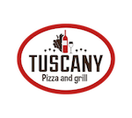
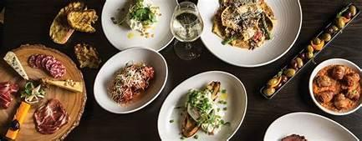

Appetizers
Mixed Brushetta
Tomatoes, Mozzarella & Sausage Gorgonzola, Mushroom & Bacon
12 pieces
$20

Italian Meat and Cheese Tray Feeds 4
$25

Smoked Salmon Brushetta Smoked Salmon, Tomatoes & fresh Dill
Feeds 4
$20

Salads
Tuscan Salad
Mixed Greens, Tomatoes & Mozzarella
Feeds 6
$25

Caesar Salad
Romaine Lettuce, Romano Cheese & Croutons
Feeds 6
$25

Caprese Salad
Cherry Tomatoes, Fresh Basil, Buratta Cheese, and Pesto Sauce with Balsamic Reduction
Feeds 6
$40

Breadsticks 10 for $12 served with our homemade garlic sauce

Catering Menu

Pastas
Fusilli Ragu
Marinara Meat Sauce with Fusilli Pasta
Full Pan Feeds 12
$100
Fusilli Ragu
Half Pan Feeds 6
$60
Ravioli Shrimp Alfredo
Cheese Filled Ravioli, Homemade Alfredo Sauce Served with Shrimp & Zucchini
Full Pan Feeds 12
$120
Half Pan Feeds 6
$70
Baked Chicken Alfredo
Penne Pasta with our Homemade Alfredo, Chicken & Broccoli
Full Pan Feeds 12
$100
Half Pan Feeds 6
$60

Baked Shrimp Alfredo
Penne Pasta with our Homemade Alfredo Sauce Served With Shrimp & Broccoli
Full Pan Feeds 12
$ 140
Half Pan Feeds 6
$ 80

Lasagna Bolognese
Traditional Lasagna with Meat Sauce
Full Pan Feeds 12-14
$100
Half Pan Feeds 6-8
$60

Spaghetti al Pesto
Basil, Parmesan, Pecorino, Almonds, Garlic and Olive Oil
Full Pan Feeds 12
$100

Half Pan Feeds 6
$60

Penne Alla Picchio Pacchio Sausage, Bacon Served With Our homemade Creamy Tomato sauce
Full Pan Feeds 12
$100
Half Pan Feeds 6
$60

Desserts
Tiramisu
Pan Feeds 10
$50
Whole Cheesecake
Feeds 12-14
$50

Additional Information

Delivery and Set Up in 10 mile radius - $30
Delivery and Set Up over 10 miles will be determined
Warmer Deposit Returned On Pick Up
Set up with attendant for a 2 hour period

